BÁO CÁO THỰC HÀNH LAB 2

LẬP TRÌNH HƯỚNG ĐỐI TƯỢNG

**Problem Modeling and Encapsulation**

Table of Contents

1. Problem Statement of AIMS Project 2

2. Use case diagram 4

3. UML Class Diagram for use cases related to cart management 5

4. Create Aims class 6

5. Create the DigitalVideoDisc class and its attributes 7

6. Create accessors and mutators for the class DigitalVideoDisc 7

7. Create Constructor method 8

8. Create the Cart class to work with DigitalVideoDisc 10

9. Create Carts of DigitalVideoDiscs 11

10. Removing items from the cart 12

# 1. Problem Statement of AIMS Project

*Given the below problem statement of AIMS Project. Please read carefully the statement to ensure that you understand clearly the software that you will design and implement from this lab. If you have any problems, please do not hesitate to ask the professor or TA.*

There might be a future that Tiki and Sendo be in talks over a potential merger to contend other e-commerce platforms and especially those who have foreign backers. The merger of these two firms would create a Ti-do company, where “Ti” is from Tiki, and “do” is from Sendo, which means a billion-dollar company in Vietnamese. That firm, Ti-do company, would like you to help them create a brand-new system for AIMS project (AIMS stands for An Internet Media Store). Currently, there is only one type of media: Digital Video Disc (DVD).

Customers can browse the list of DVDs available in the store, the display order is based on their added date, from latest to oldest. When a customer wants to search for DVDs to add to cart, he or she can choose one of three searching options. The software will display a list of all matches (latest DVDs first) with all their information. He or she can also choose to play a specific DVD. The software will play a DVD (a demo part). If a DVD has the length 0 or less, the system must notify the customer that the DVD cannot be played.

* + When a customer searches for DVDs by title, he or she provides a string of keywords. If any DVD has the title containing any word in the string of keywords, it is counted as a match. Note that the comparison of words here is case-insensitive.
  + When a customer searches for DVDs by category, he or she provides the category name. If any DVD has the matching category (case-insensitive), it is counted as a match.
  + When a customer searches for DVDs by price, he or she provides either the minimum and maximum cost, or just the maximum cost.

Customers can view the detail information of a DVD from the list of DVDs. He/she can add a DVD to a cart from a list of DVDs or the detail screen.

When a customer wants to see the current cart, the system displays all the information of the DVDs, along with the total cost. Customers may listen to a DVD (a demo part) in the cart before confirming to place an order. Customers can sort all DVDs in the cart by title or by cost:

* Sort by title: the system displays all the DVDs in the alphabet sequence by title. In case they have the same title, the DVDs having the higher cost will be displayed first.
* Sort by cost: the system the system displays all the DVDs in decreasing cost order. In case they have the same cost, the DVDs will be ordered by increasing title.

Customers can update the quantity of a DVD in a cart or remove a DVD from a cart. To increase consumer demand for the product and grow sales, customers are allowed to have an item for free which is randomly picked out in the cart by the system. Customers can filter DVDs in the cart by providing either its ID or title. If the item is found, display information of the found item in the cart. Or else, notify the customer the item is not found in the current cart.

The customer can request to place order when they are seeing the current cart. For simplification, he/she does not need to log in to place an order. The application will prompt the customer to enter the delivery information and delivery instructions. The software will then calculate the delivery fee based on the total mass of the order & the delivery location. Then, it will display to the customer the invoice including the DVD list, total cost before VAT, total cost after VAT, and the delivery fee. The customer can then proceed to pay for the order. Currently, only one payment method – i.e. credit card – is allowed by connecting to a card association system for checking the validation of the card or performing the pay transaction. After the transaction, the AIMS software will display all the detailed information such as transaction ID, card owner, transaction amount, transaction message, balance, transaction date to the customer. The order will be in pending state and the information of the order & the transaction will be sent to the customer’s email.

The store manager needs to log in to the system to navigate to the management mode. He/she can see the list of pending orders, then can pick any order to see its detail to approve or reject the order. The store manager can add new DVDs to the store. He or she must provide all information of the new DVD, including its ID, title, category, director, length, and the cost. Additionally, the manager can also remove DVDs from the store.

# 2. Use case diagram

*Based on the problem statement in the section 2, please draw the use case diagram using Astah UML for the AIMS project.*

*Kết quả :*

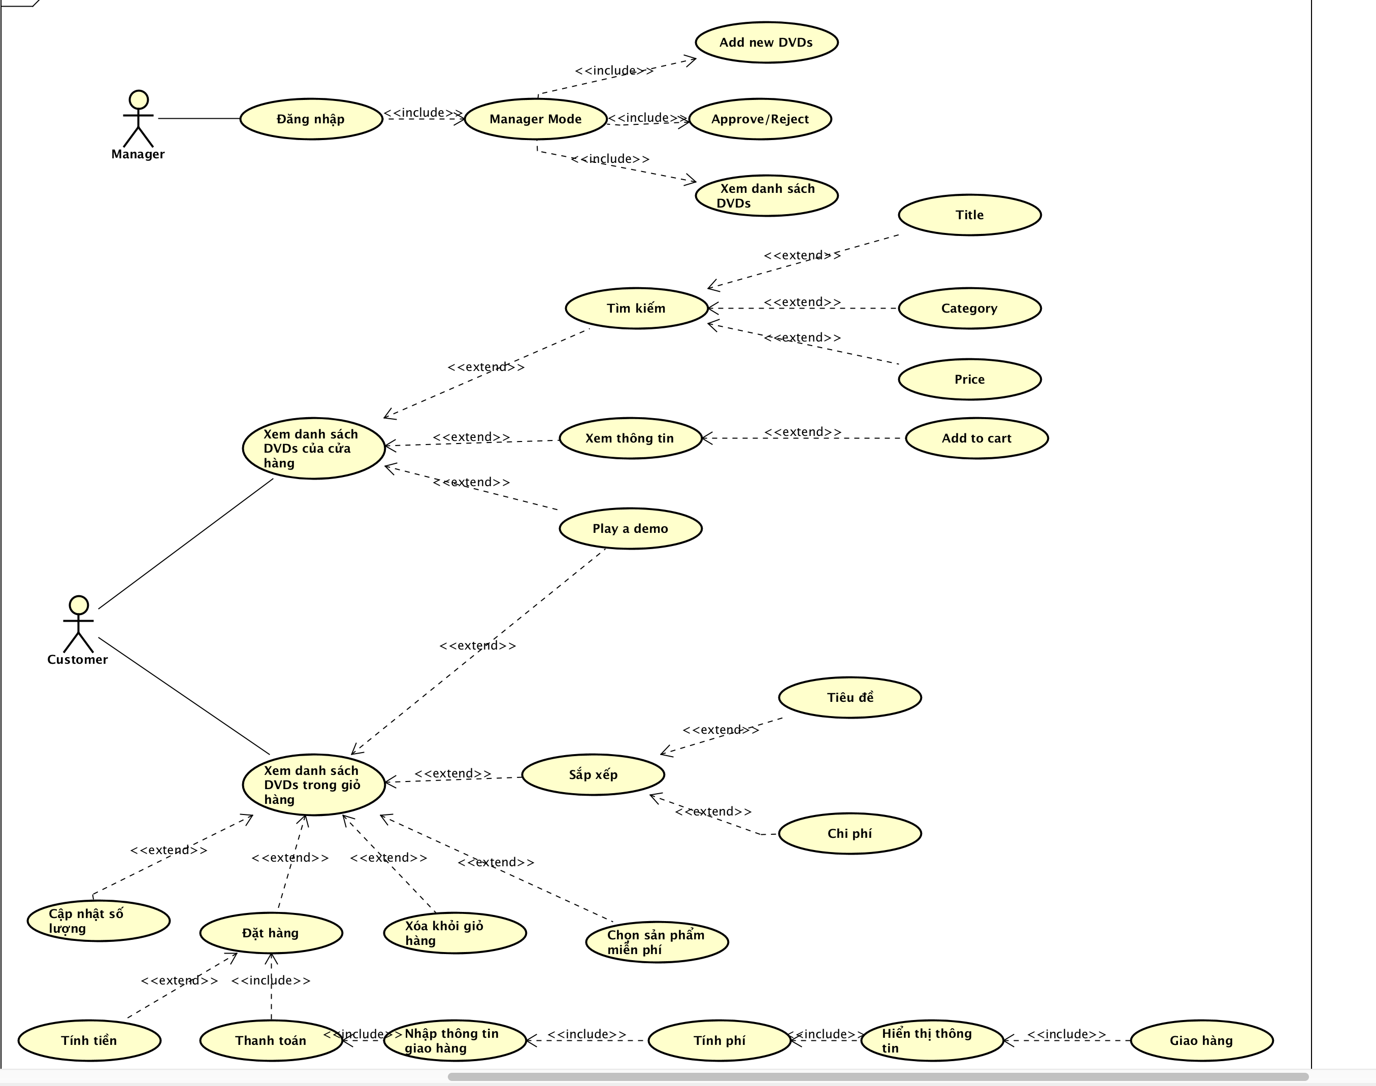

# 3. UML Class Diagram for use cases related to cart management

The system needs to create a new cart for the user, where it will keep information on the DVDs that the user wants to buy. The user can add, remove DVDs from the cart as well as calculate the cost. The user can add maximum of 20 DVDs into one cart. The cart with its information and behaviors is modeled with the **Cart** class. When the user adds a DVD to the cart, the system must also create a new DVD based on the information that the user provides. This information can be displayed whenever the user decides to see it. The DVD with its information and functions is modeled with the DVD class. Finally, the application needs an entry point for displaying to and taking input from the user (via a command-line interface), which will be the Aims class. A sample class diagram is illustrated in **Error! Reference source not found.**, which includes 3 classes:

* The **Aims** class which provides a main() method which interacts with the rest of the system
* The **DigitalVideoDisc** class which stores the title, category, cost, director and length
* The **Cart** class to maintain an array of these DigitalVideoDisc objects

***You have to update this class diagram following the below exercises for the final submission.***

*Kết quả :*

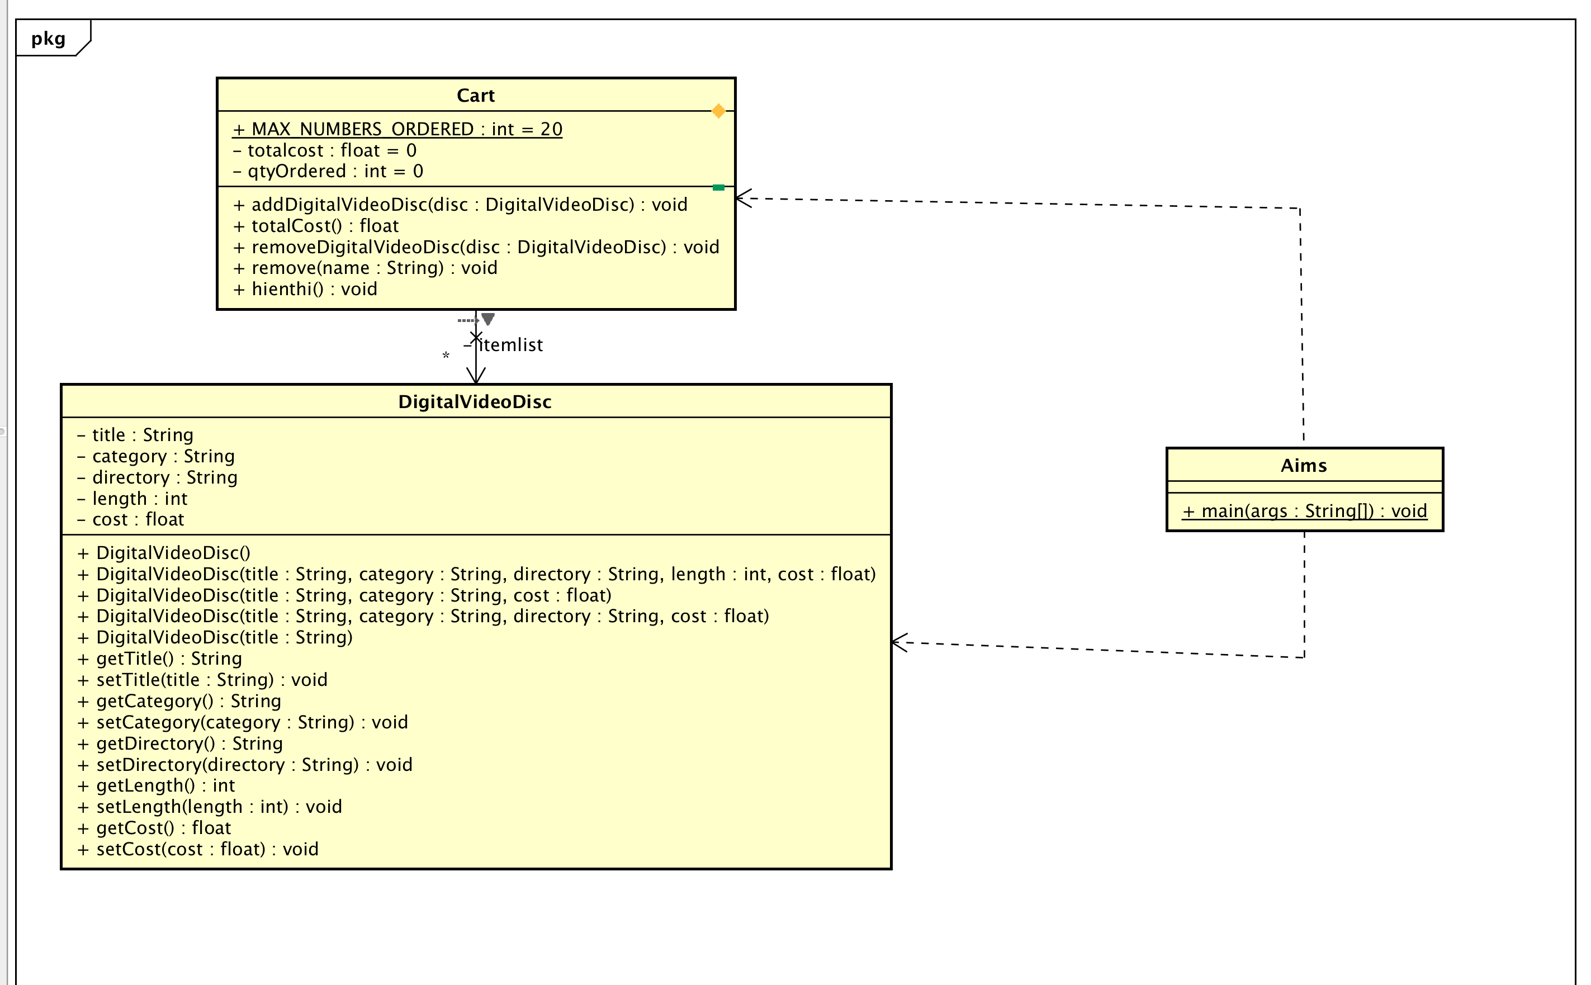

# 4. Create Aims class

*Kết quả* :

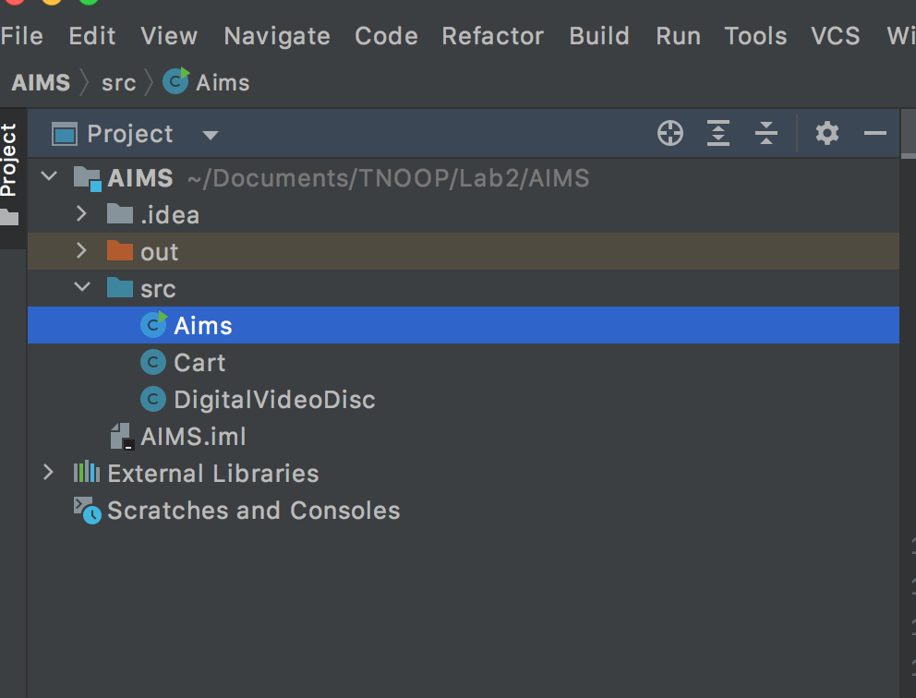

# 5. Create the DigitalVideoDisc class and its attributes

*Kết quả :*

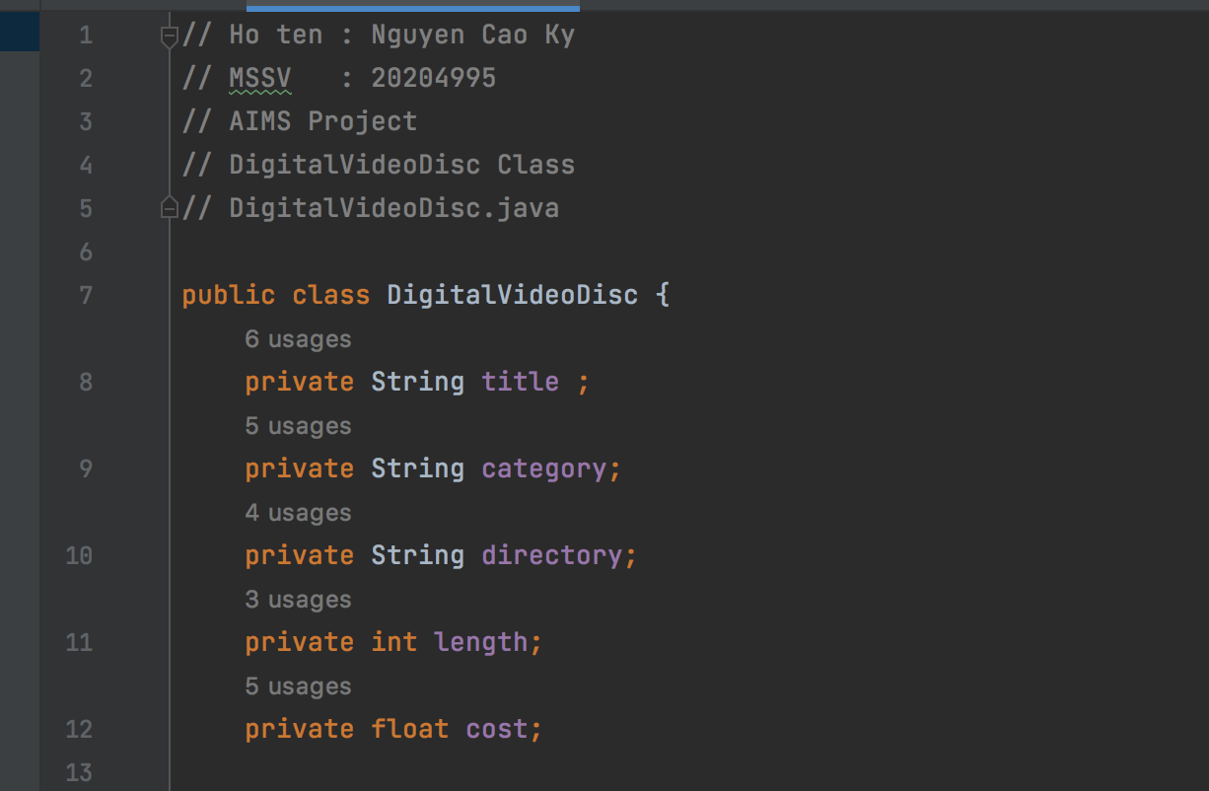

# 6. Create accessors and mutators for the class DigitalVideoDisc

*Kết quả*

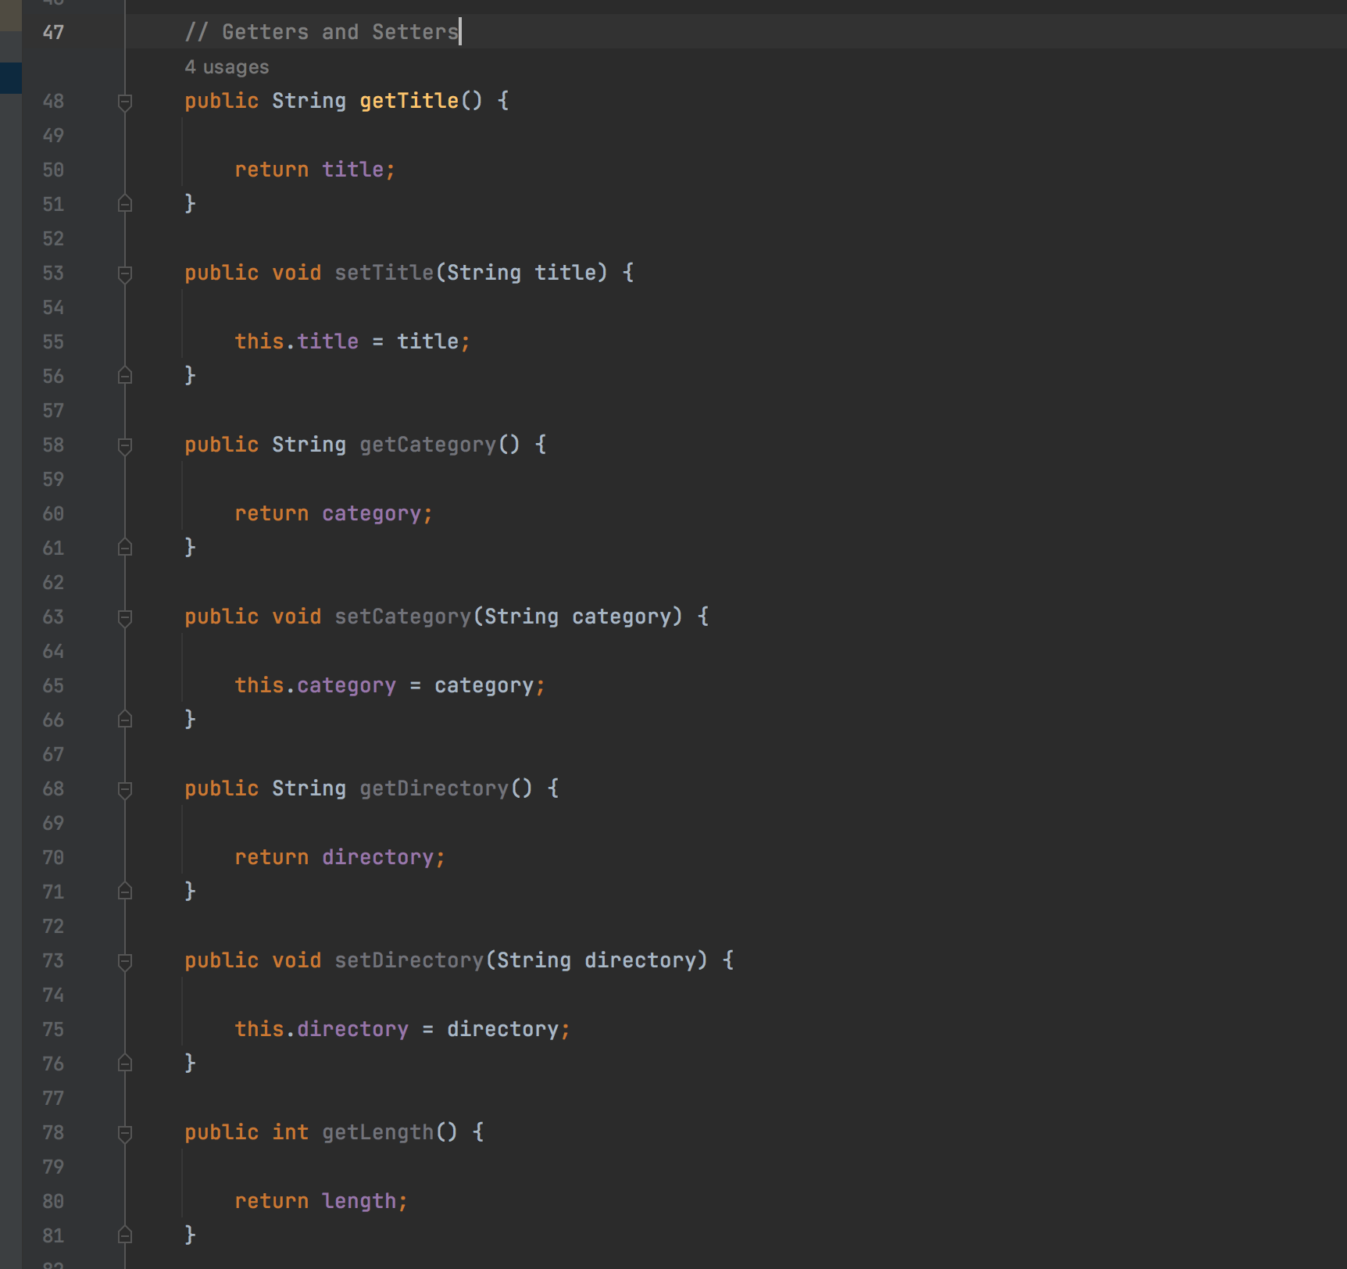

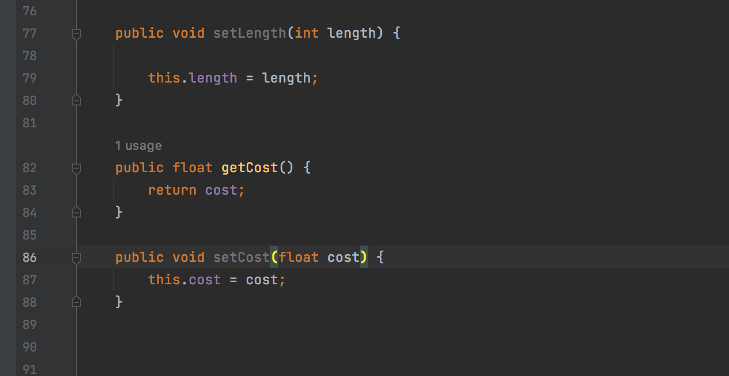

# 7. Create Constructor method

In this part, you will create yourself constructor method for DigitalVideoDisc for different purposes:

- Create a DVD object by title

- Create a DVD object by category, title and cost

- Create a DVD object by director, category, title and cost

- Create a DVD object by all attributes: title, category, director, length and cost

*Kết quả :*

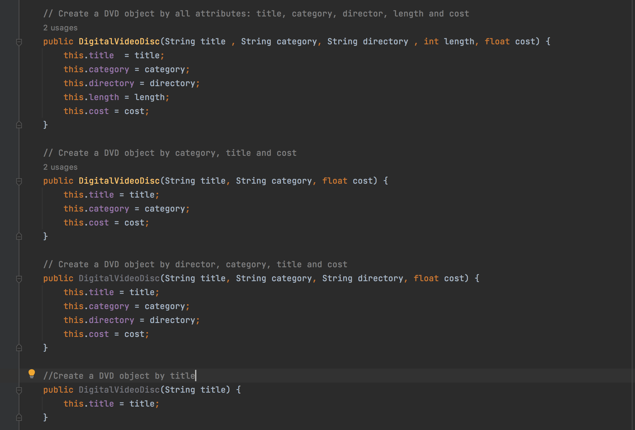

# 8. Create the Cart class to work with DigitalVideoDisc

*Kết quả :*

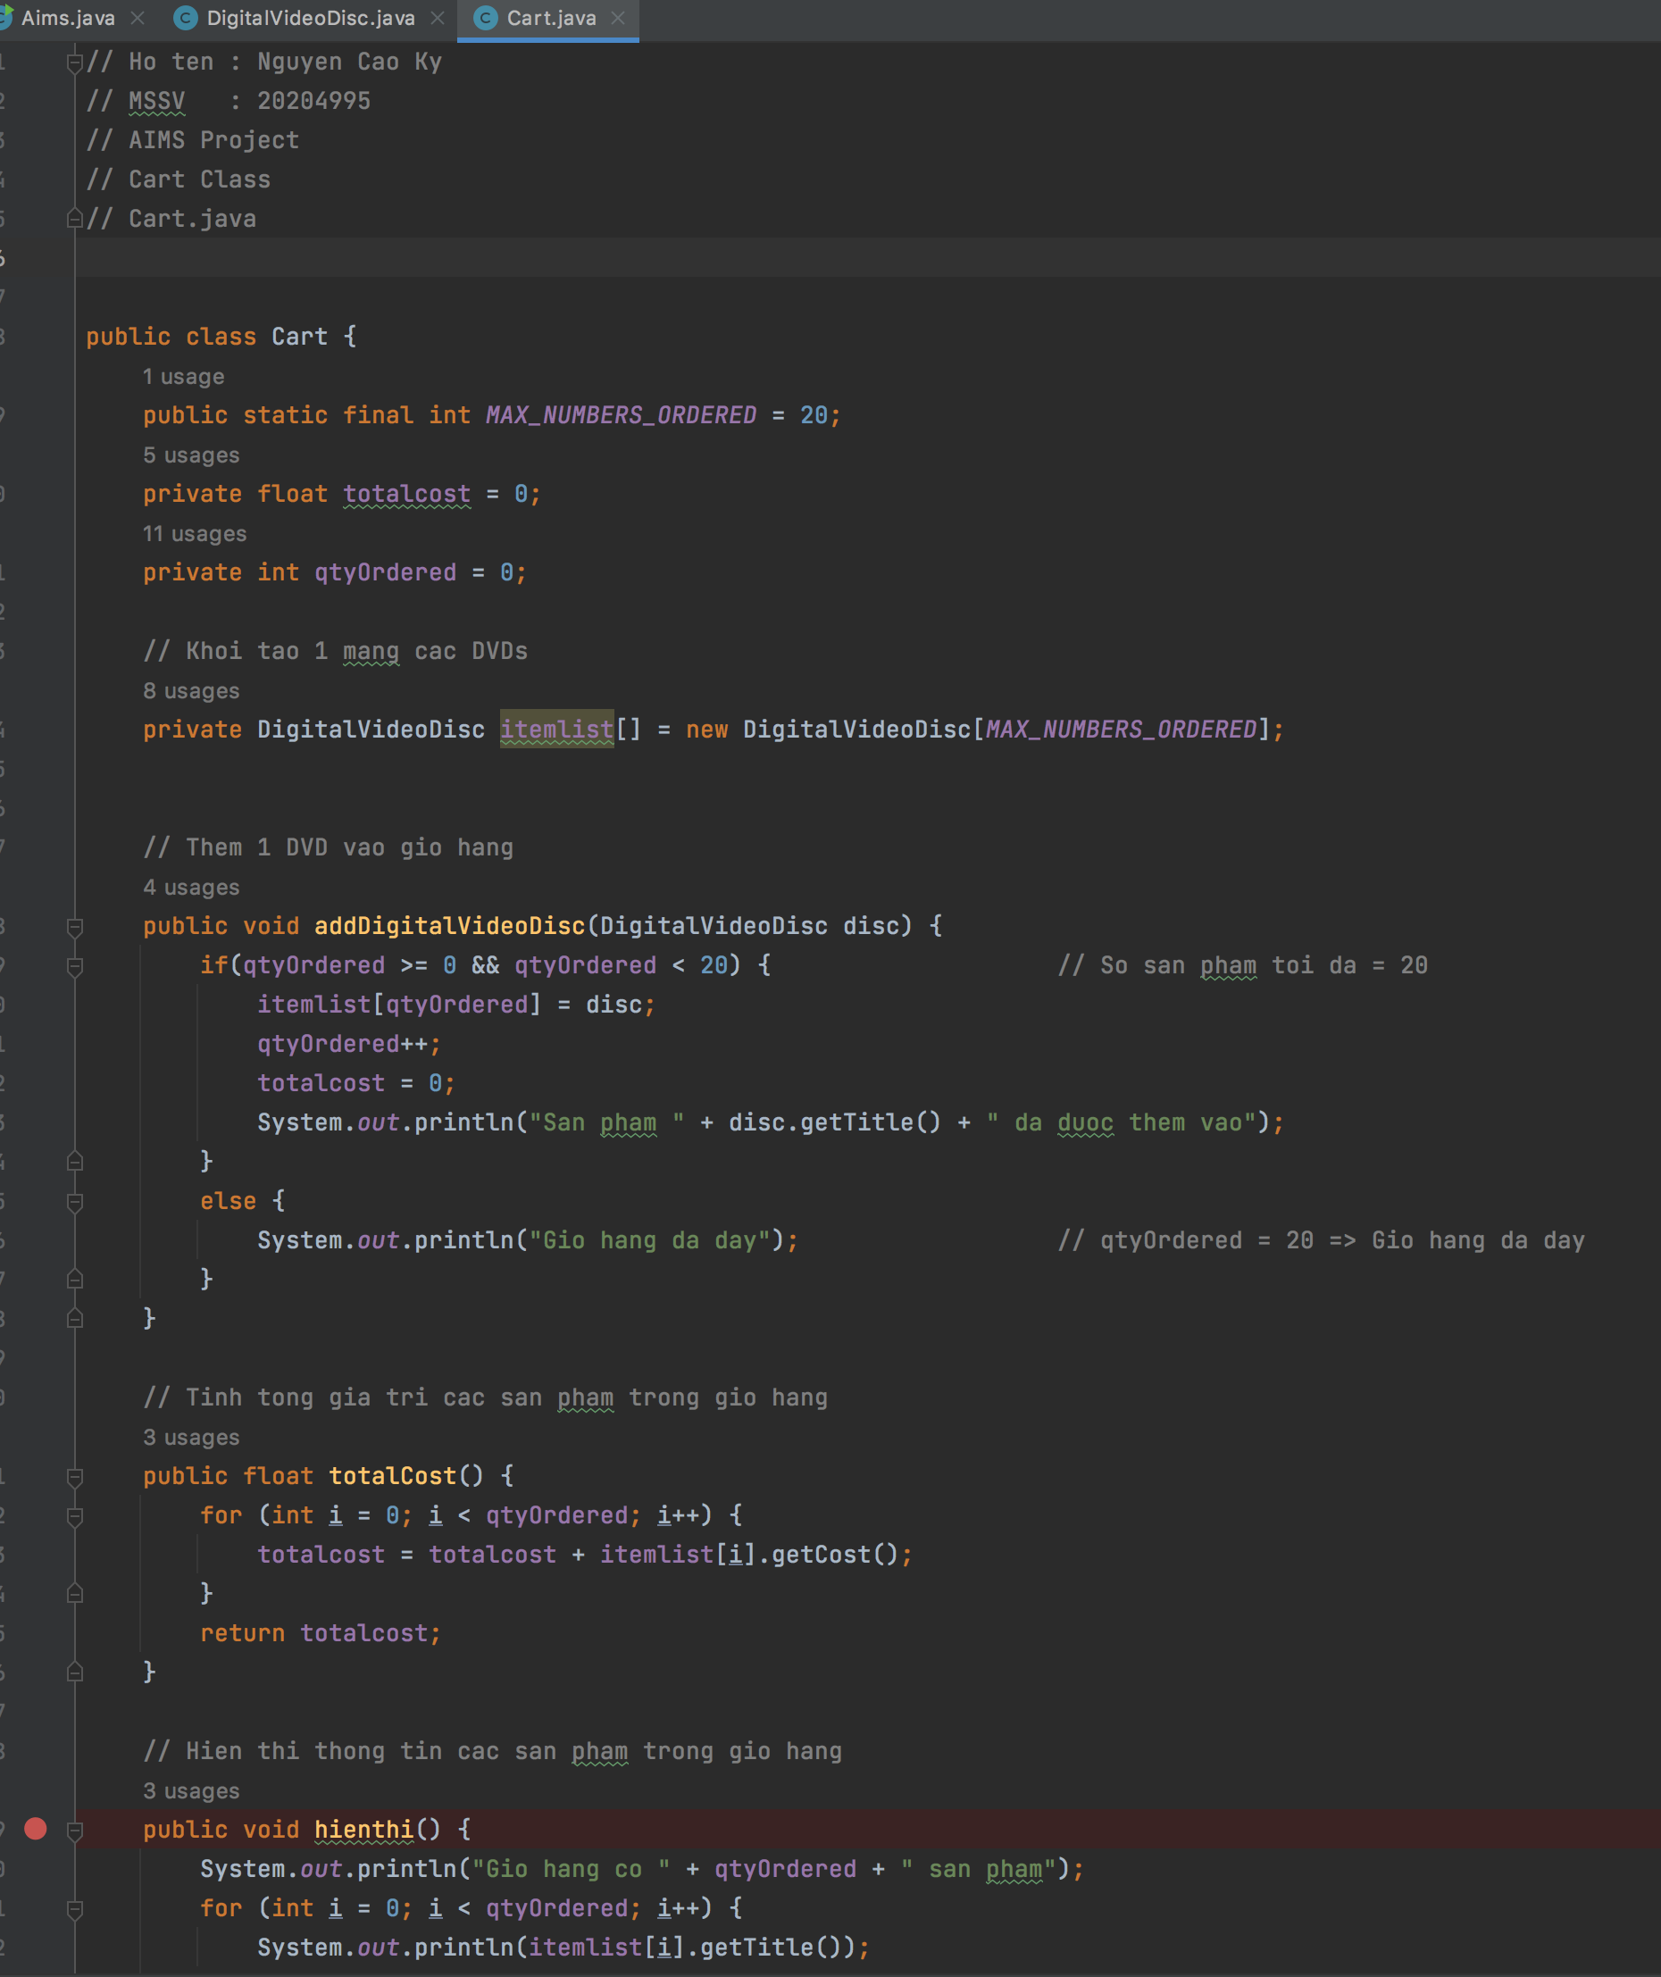

# 9. Create Carts of DigitalVideoDiscs

*Aims Class :*

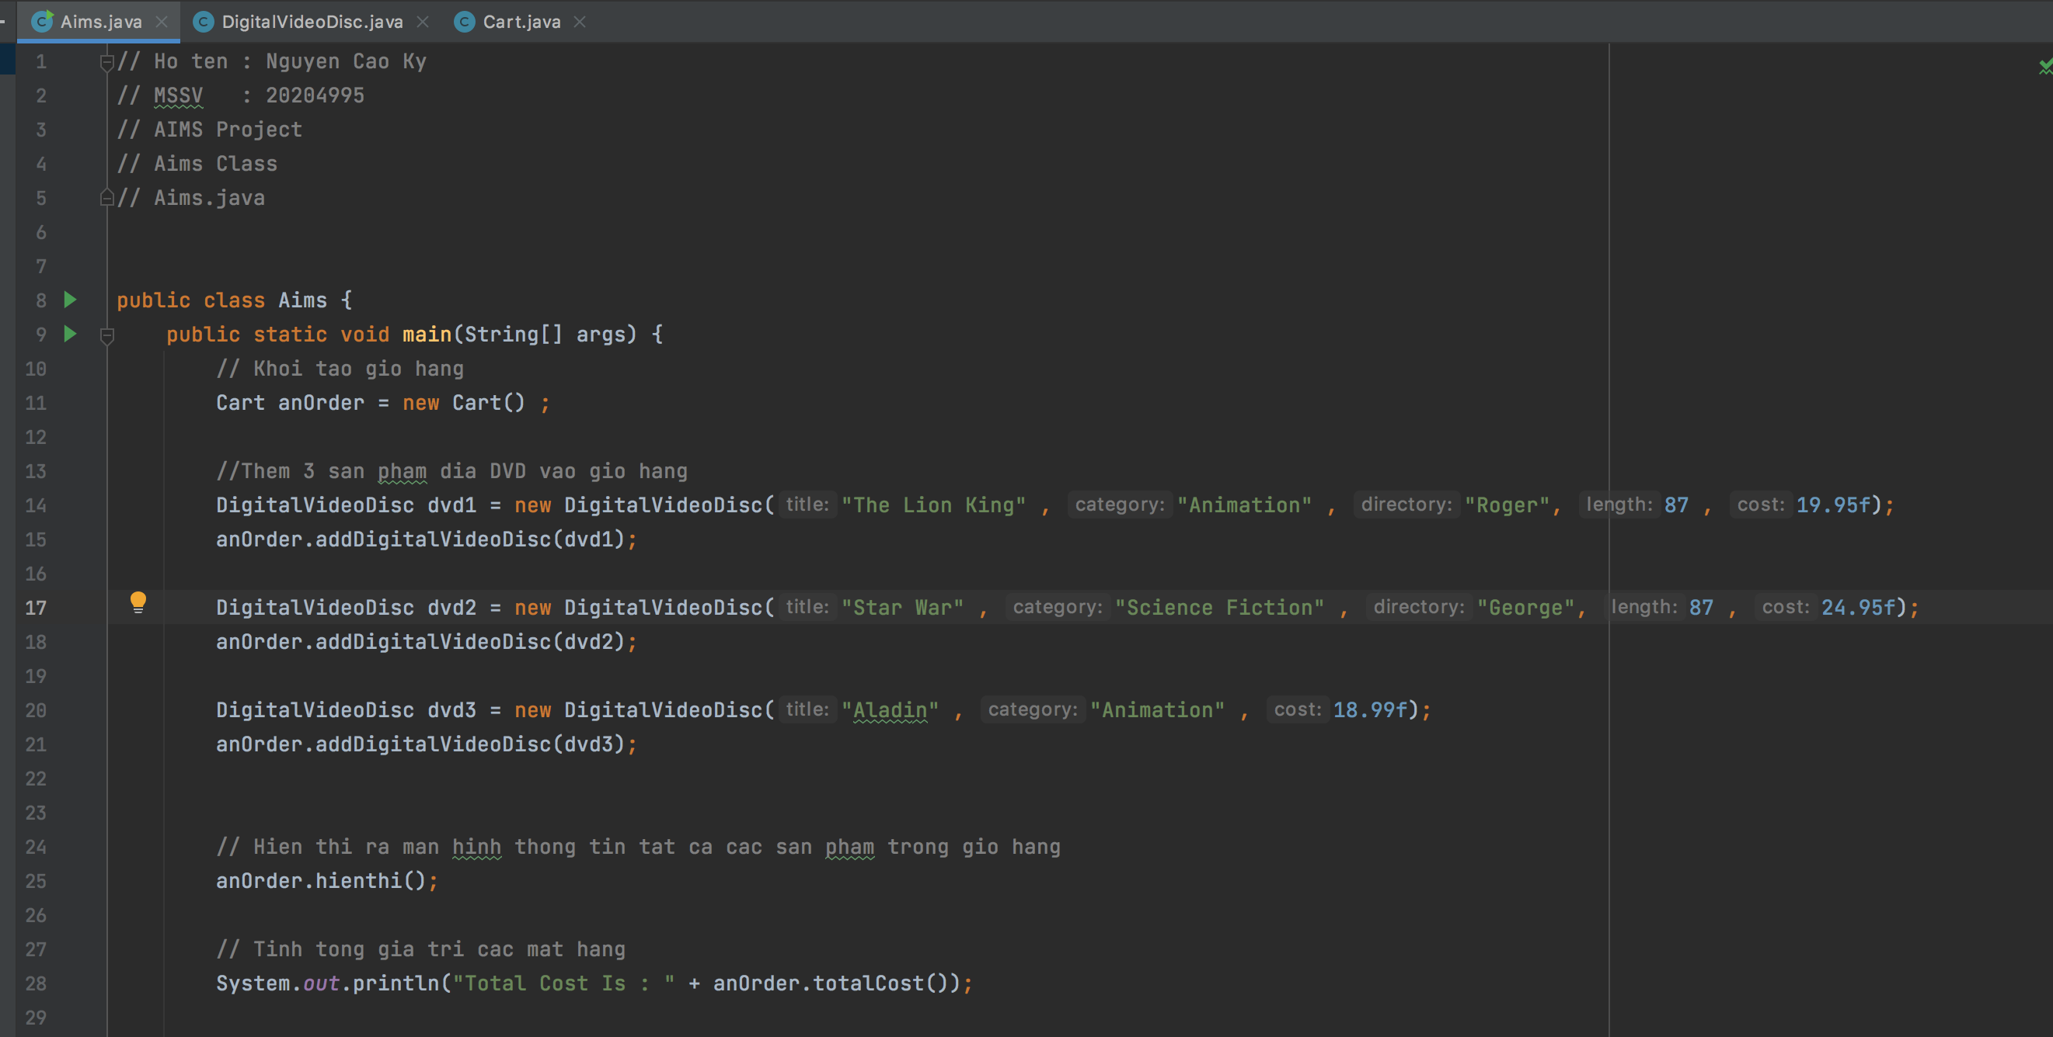

*Kết quả chạy chương trình :*

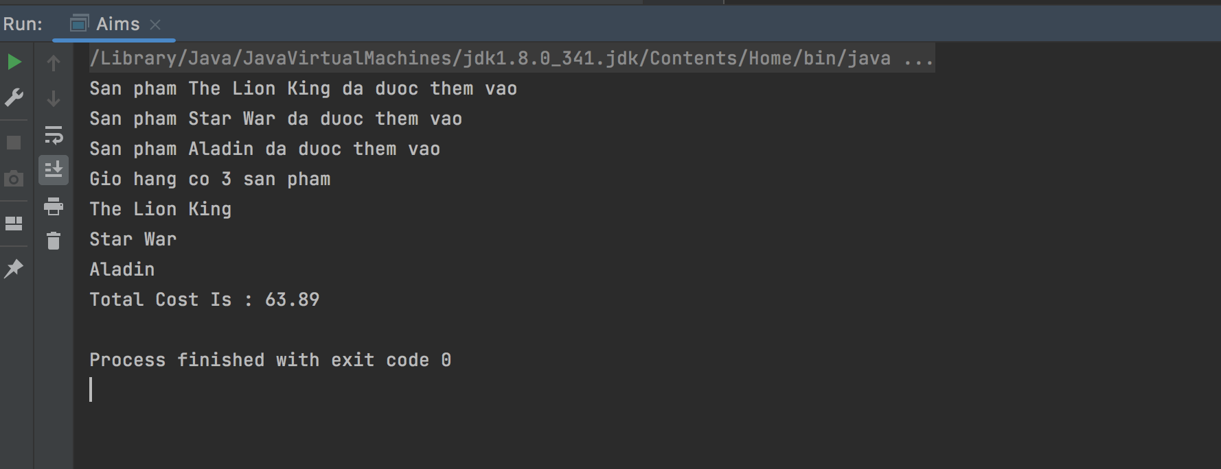

# 10. Removing items from the cart

Có thể xóa trực tiếp sản phẩm hoặc tìm kiếm sản phẩm tương ứng với đầu vào là Title , sau đó xóa sản phẩm.

*Cart Class :*

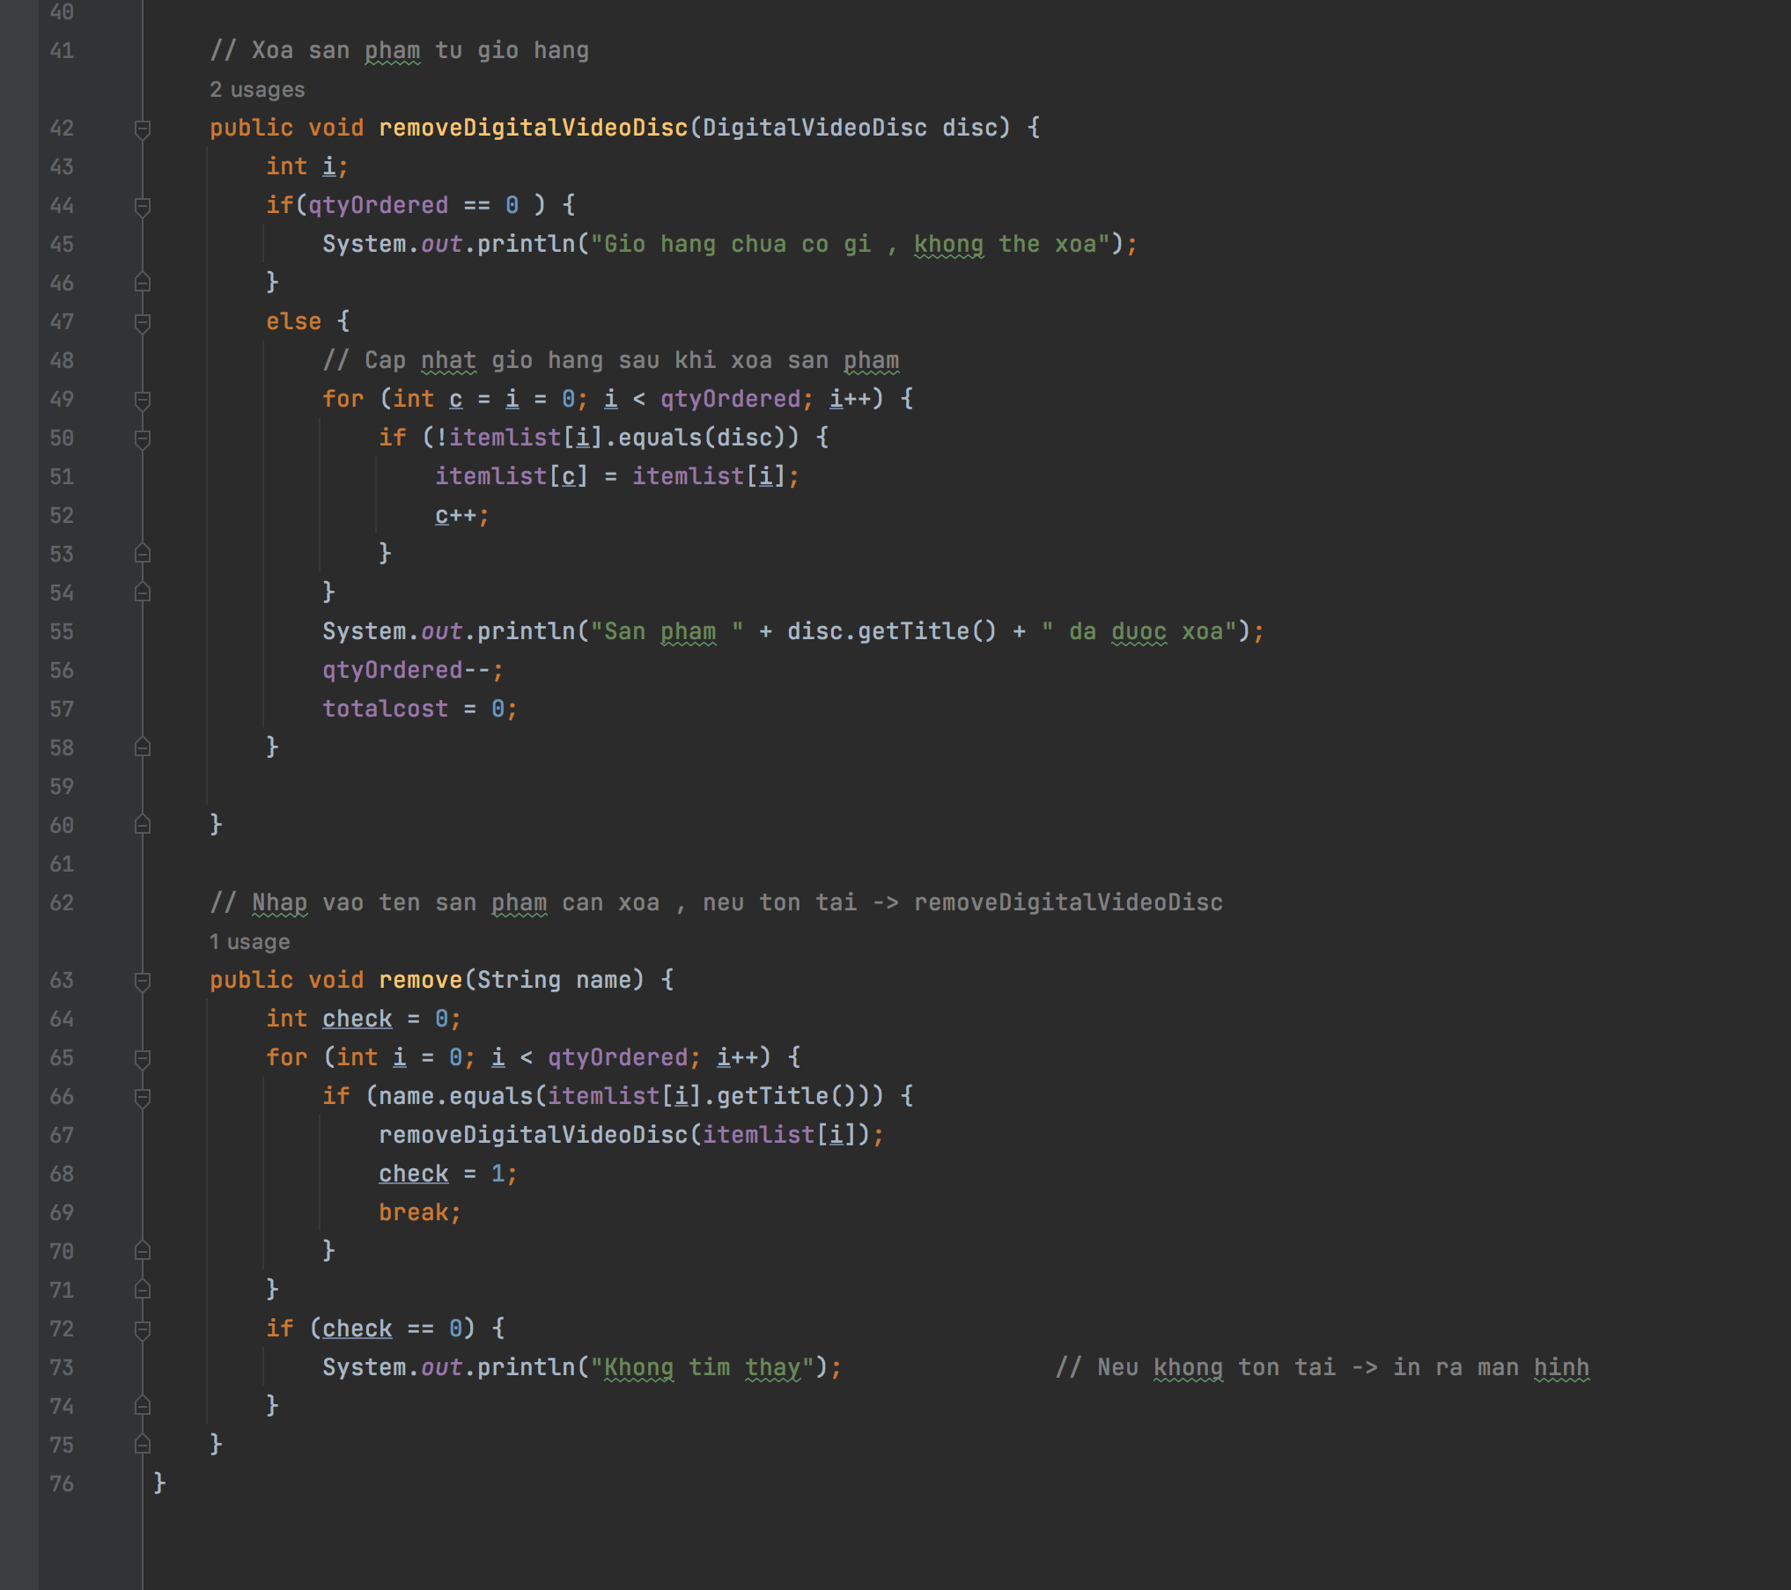

*Aims Class :*

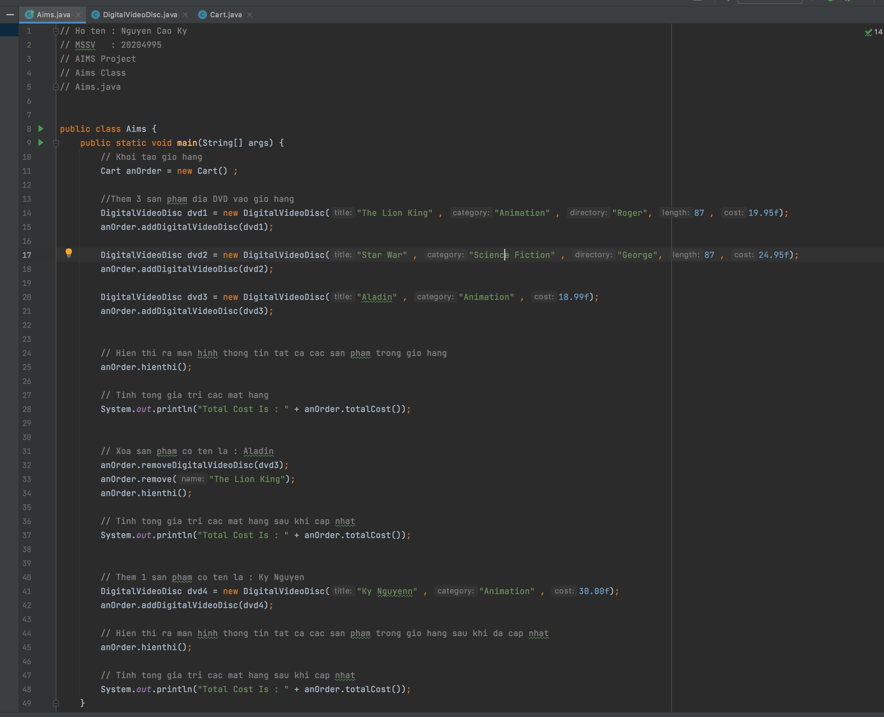

* Thêm 3 sản phẩm : “The Lion King” , “Star War” , “Aladin” vào giỏ hàng . Hiển thị ra màn hình thông tin và tổng giá trị giỏ hàng.
* Xóa dvd3 và sản phẩm có tiêu đề : “The Lion King” . Hiển thị ra màn hình thông tin và tổng giá trị giỏ hàng sau khi cập nhật.
* Thêm sản phẩm có tiêu đề : “Ky Nguyen” vào giỏ hàng. Hiển thị ra màn hình thông tin và tổng giá trị giỏ hàng sau khi cập nhật

*Kết quả chạy chương trình :*

